What is a Machine Learning Model? 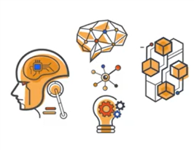

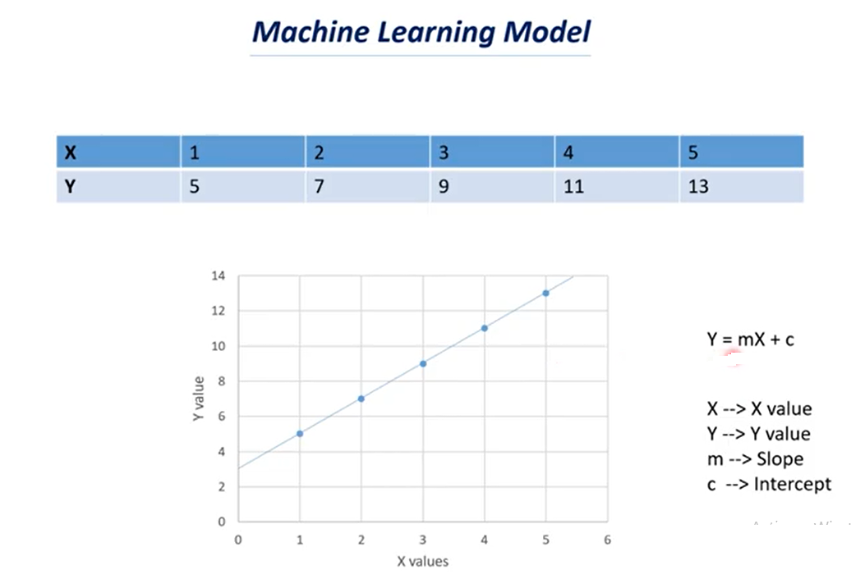

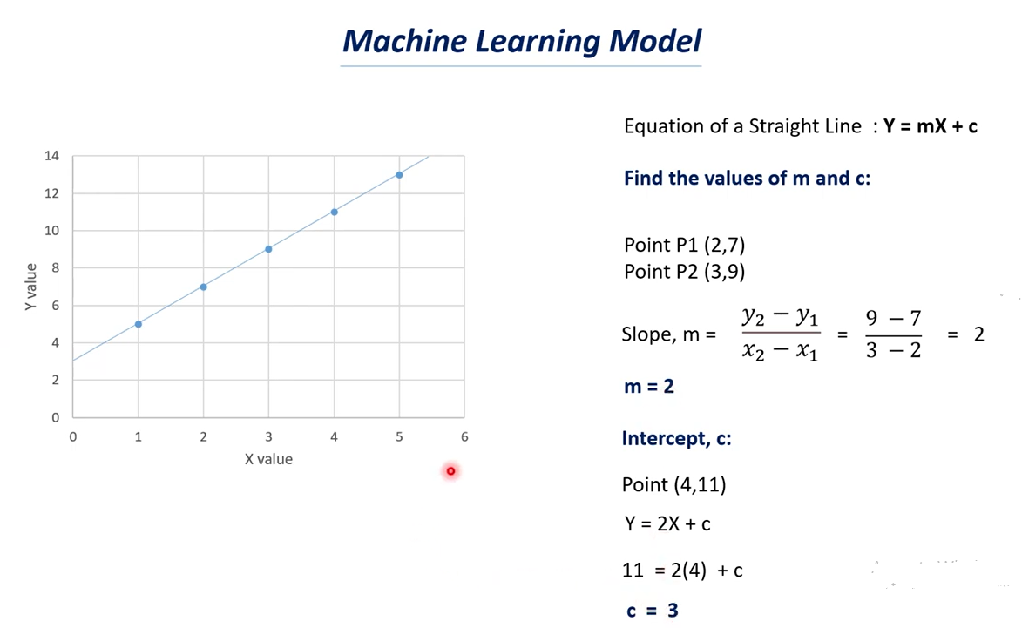

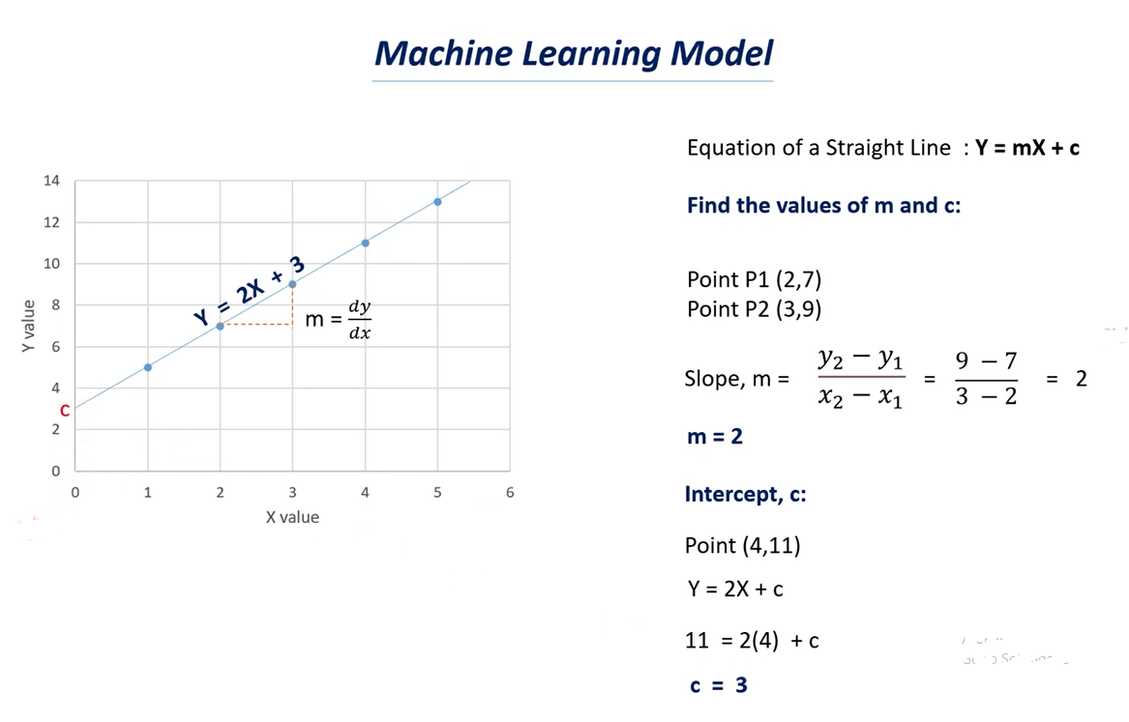

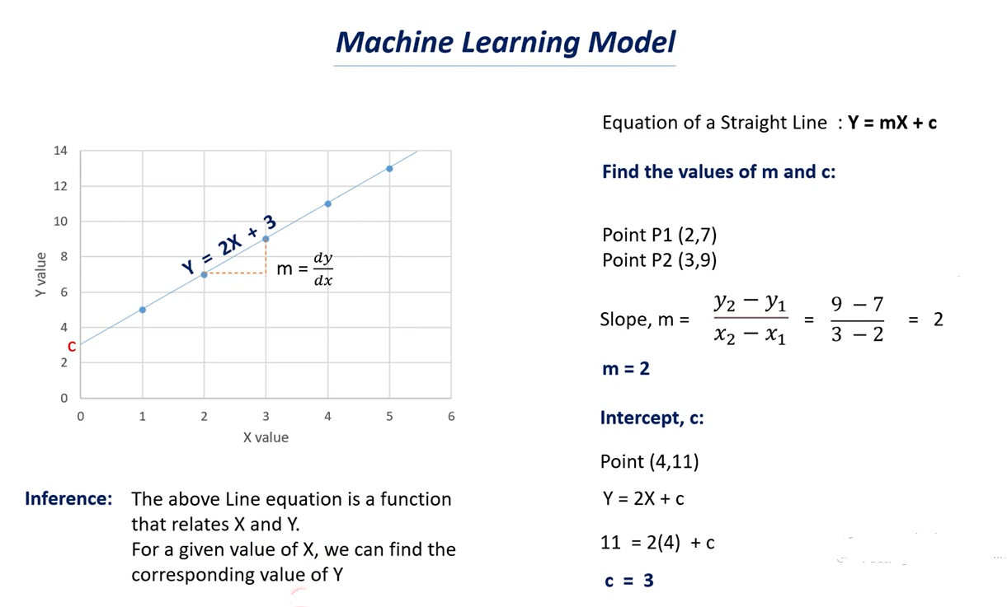

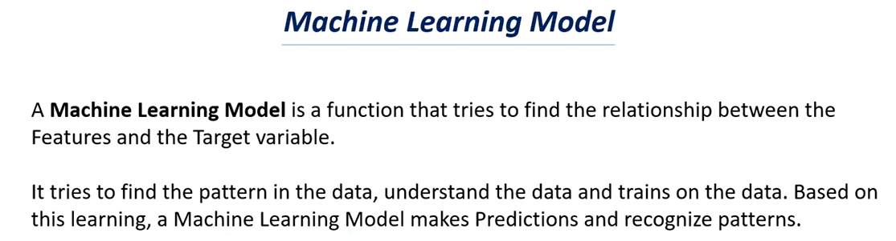

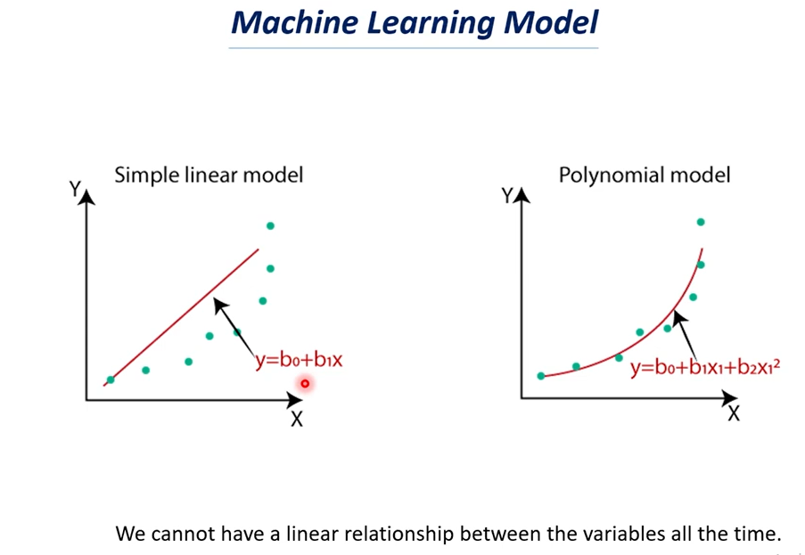

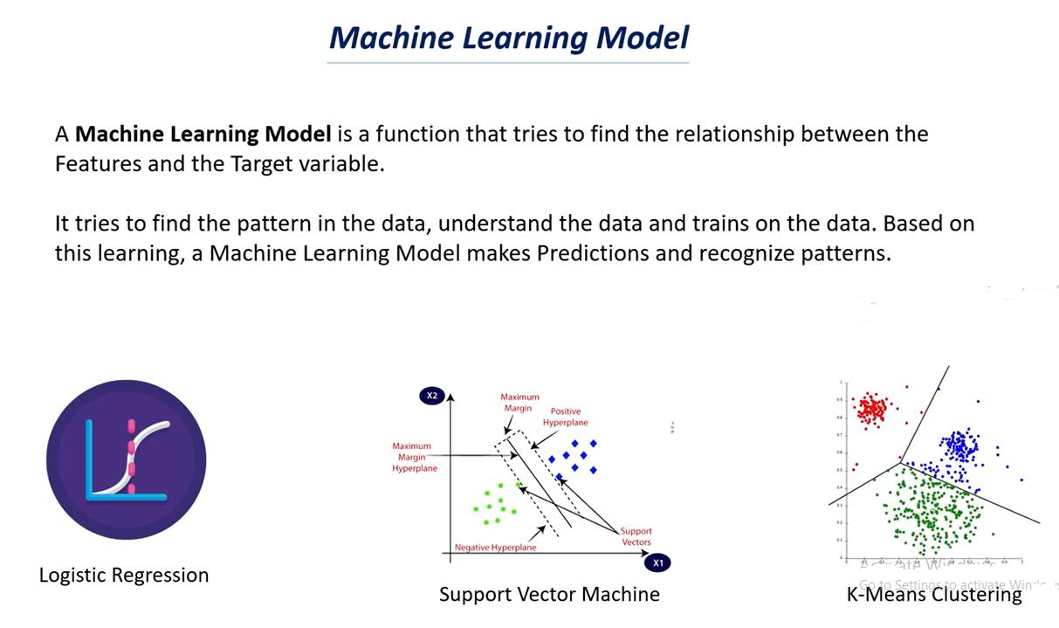

# Supervised Learning Models | Supervised Learning

# 

# 

# 

# 

# Unsupervised Learning Models | Unsupervised Learning

# 

# 

# 

# 

# 

# How to choose the right Machine Learning Model ,Model Selection ,Cross Validation

# 

# 

# 

# 

# 